 Creating First Package in SSIS

Tools Required:

To create an SSIS Package for we need to have [SQLSERVER 2012 Evaluaion Edition](https://www.blogger.com/blog/post/edit/8488725265119073101/5726752252125397364) installed in our system. Which contains all of the four tools of MSBI

* SQL Server Management studio.
* SQL Server Reporting Services.
* SQL Server Integration Services.
* SQL Server Analysis Services.

Steps for creating the 1st SSIS Package:

Step 1: Install [SQLSERVER 2012 Evaluaion Edition](https://www.blogger.com/blog/post/edit/8488725265119073101/5726752252125397364) and Open up SQL server data tool in the system.

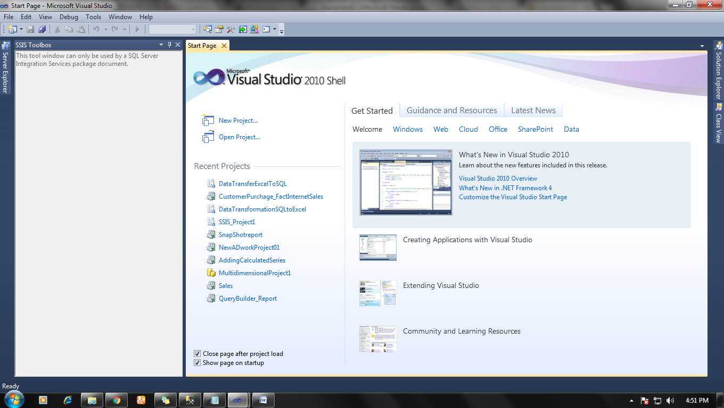

Click on a new project and select Business intelligence > Integration services and Name you Project and its location and hit ok.

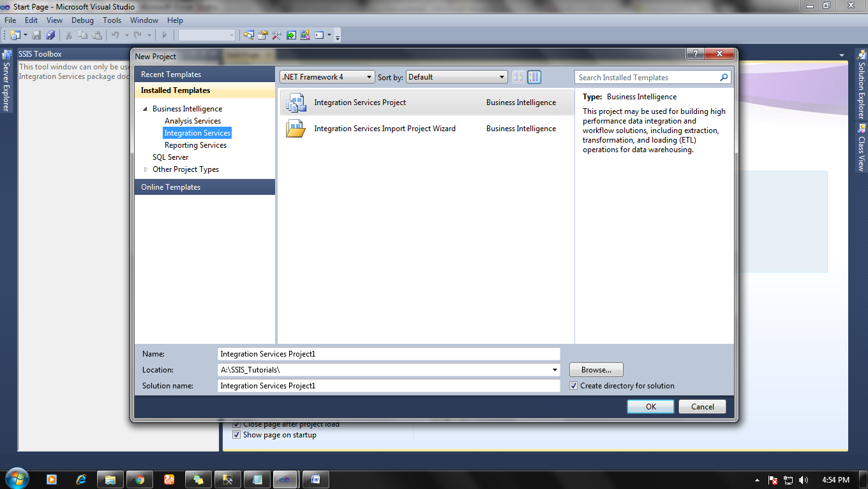

**Step 2:** a new window will open with three sub-windows.

  SSIS Solutions, Package design and SSIS tools.

In Solution explorer there are three options:

* Connection manager
* SSIS packages
* miscellaneous

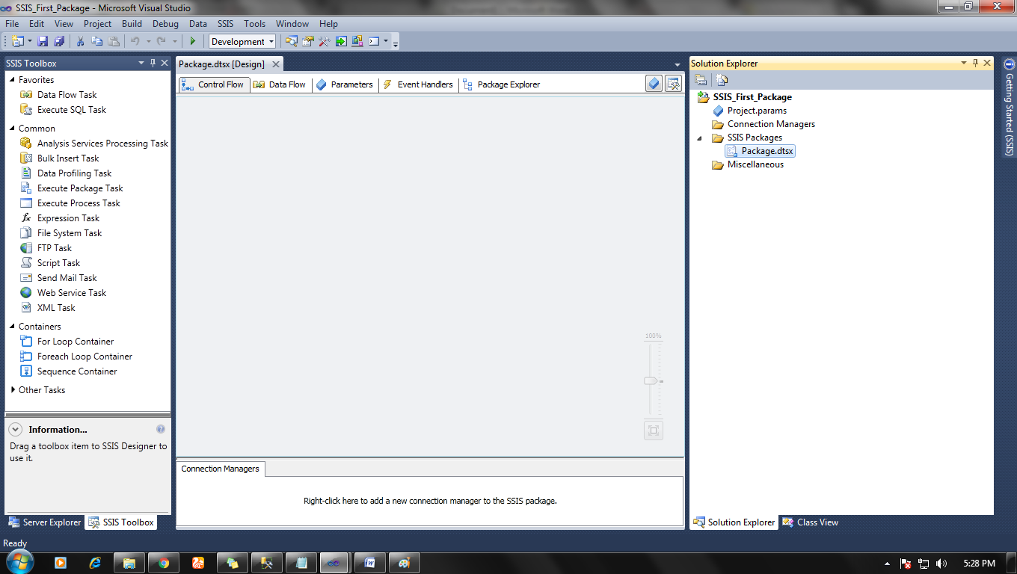

**Step 3:** Setting up the connection of data source for the project. To select the data source for the project right click on connection manager and select add a new connection.

A new window will open from where you can select data source connection for the project.

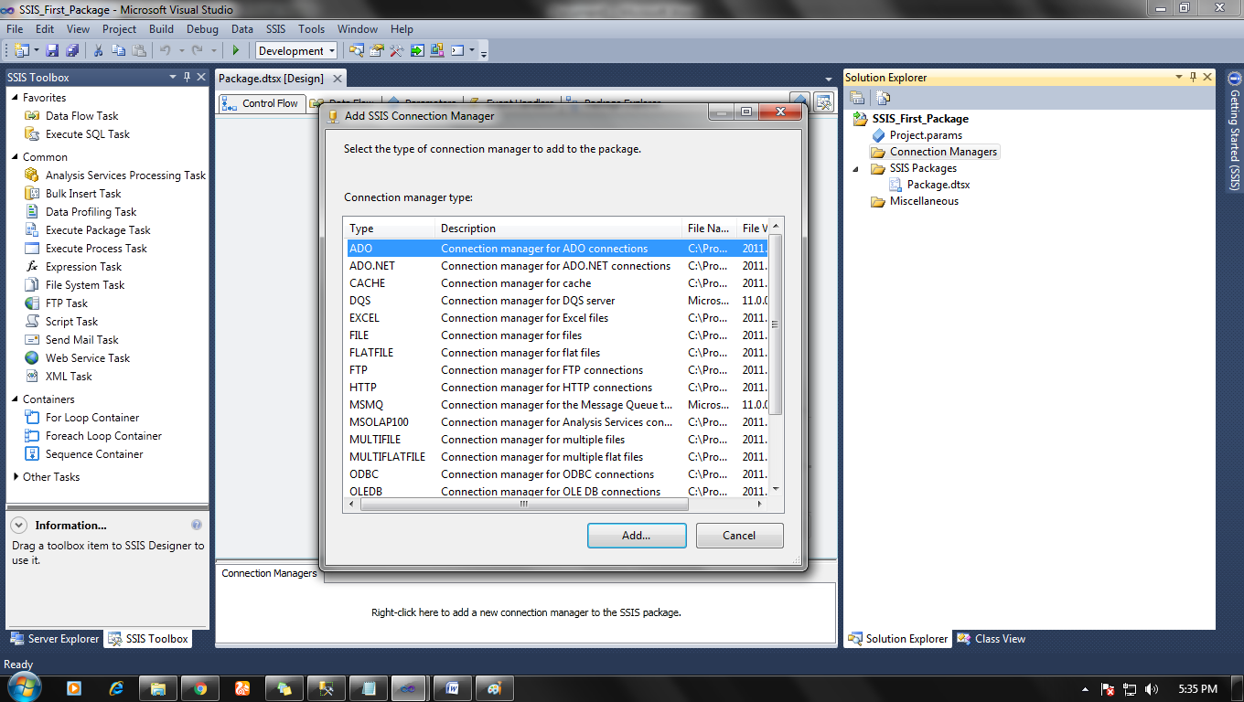

Any data source can be select as our requirement. Like Excel, SQL, Oracle, Flat file etc.

**Step 4:** After making project connection with database and data source, Select Control Flow tab in Package design and then click on data flow option in SSIS > Favorites > Data Flow and drop it in Package Design>control flow tab.

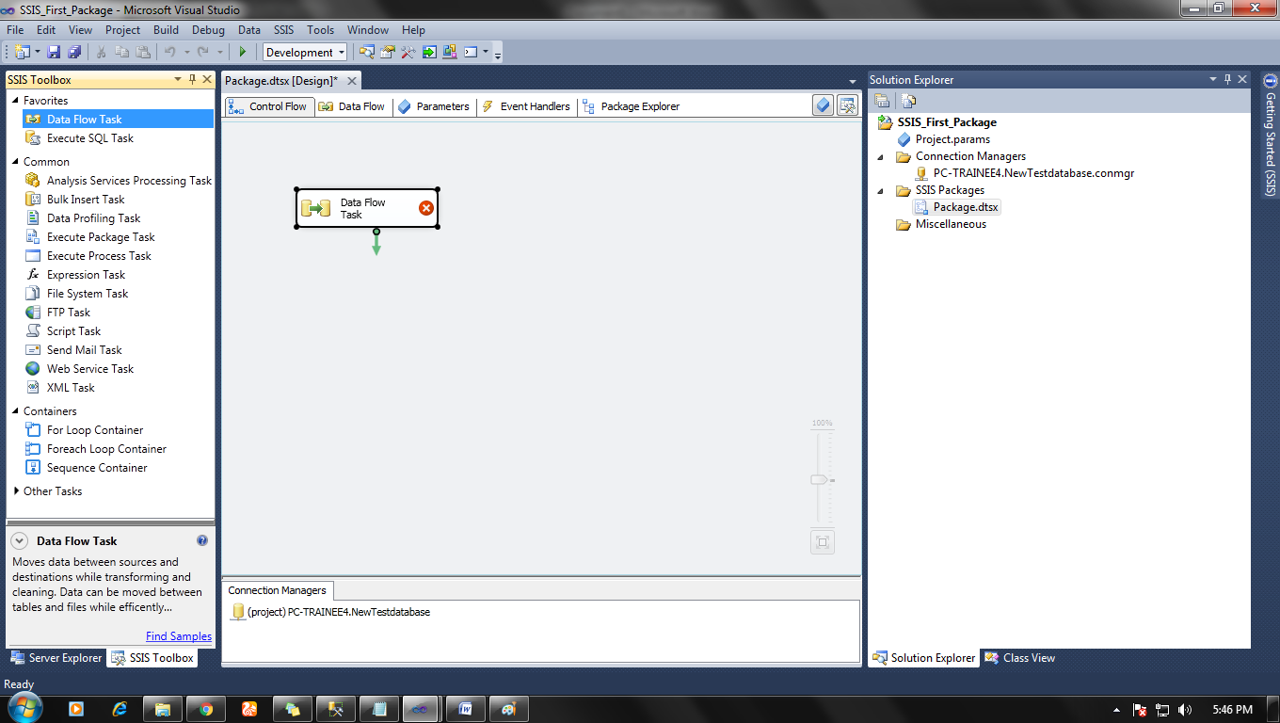

**Step 5:** Double click on Data flow icon in Control flow tab and it would redirect you to Data flow tab in Package design.

Then Select from Package design>data flow>SSIS Tool>Favorites>Source Assistance

And make a data source in the data flow tab.

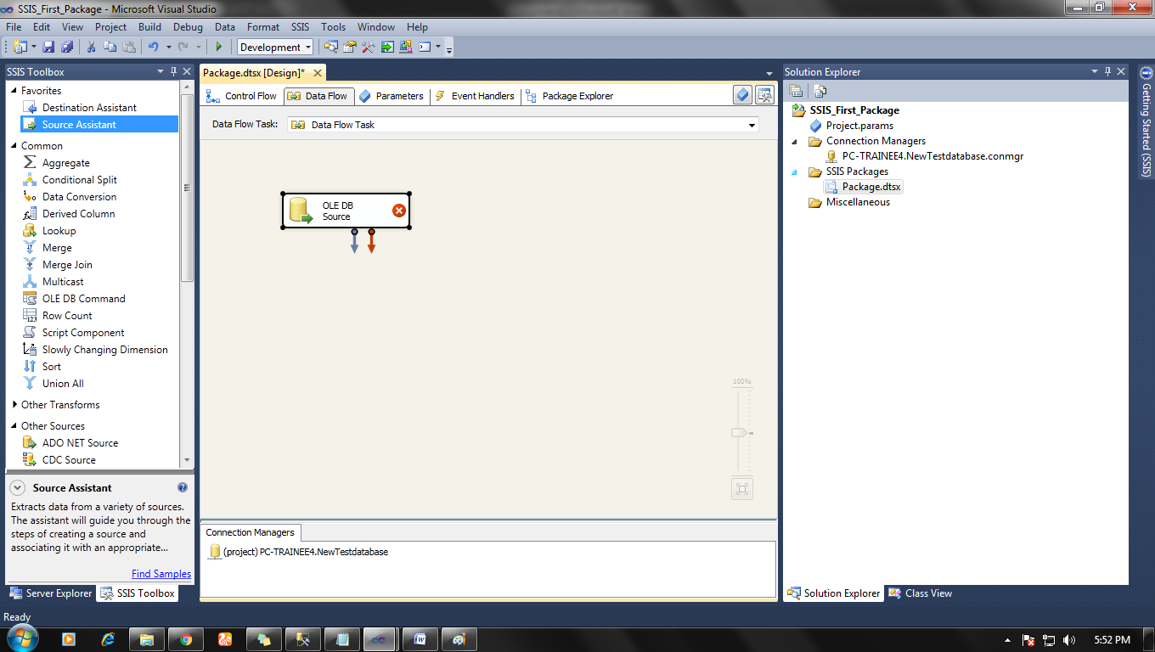

Now double click on data source icon. In my case it is OLE DB Source > A new window would open and select right connection manager and right Source table.

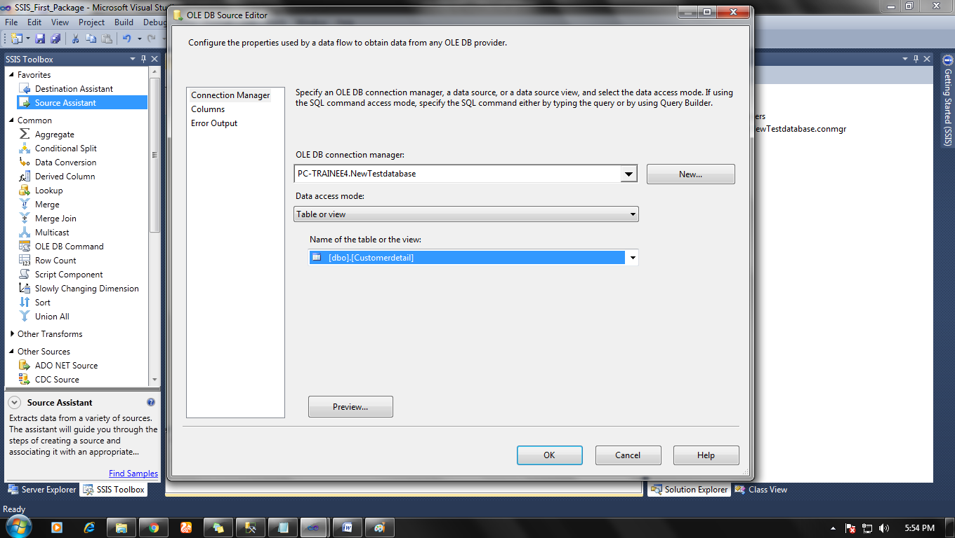

Click ok.

**Step 6:** From SSIS tools>Others Destinations,  Select your desire destination type (here we have selected Flat file destination) and drag and drop it in Data flow tab.

Click on the data source file and link arrow sign with data destination.

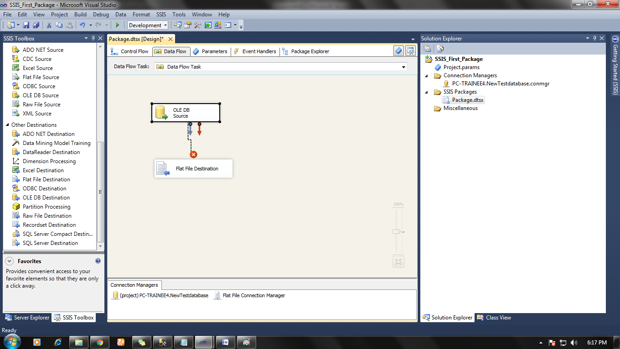

After it, double click on flat file destination icon and set new connection by click on new and set destination file, click ok.

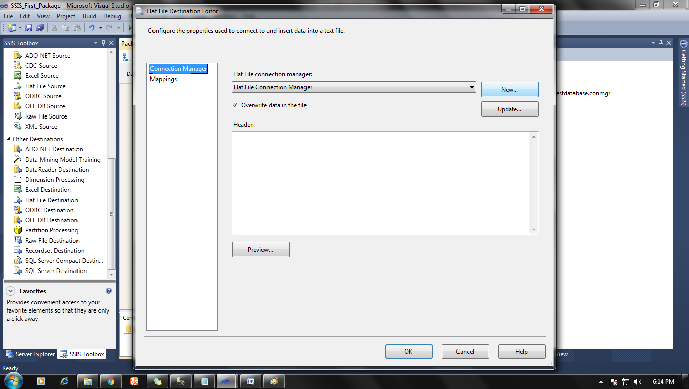

**Step 7**: Now everything is done and it’s time to execute our first package.

Right-click anywhere in the data flow tab and select execute the task and you will see a result like below.

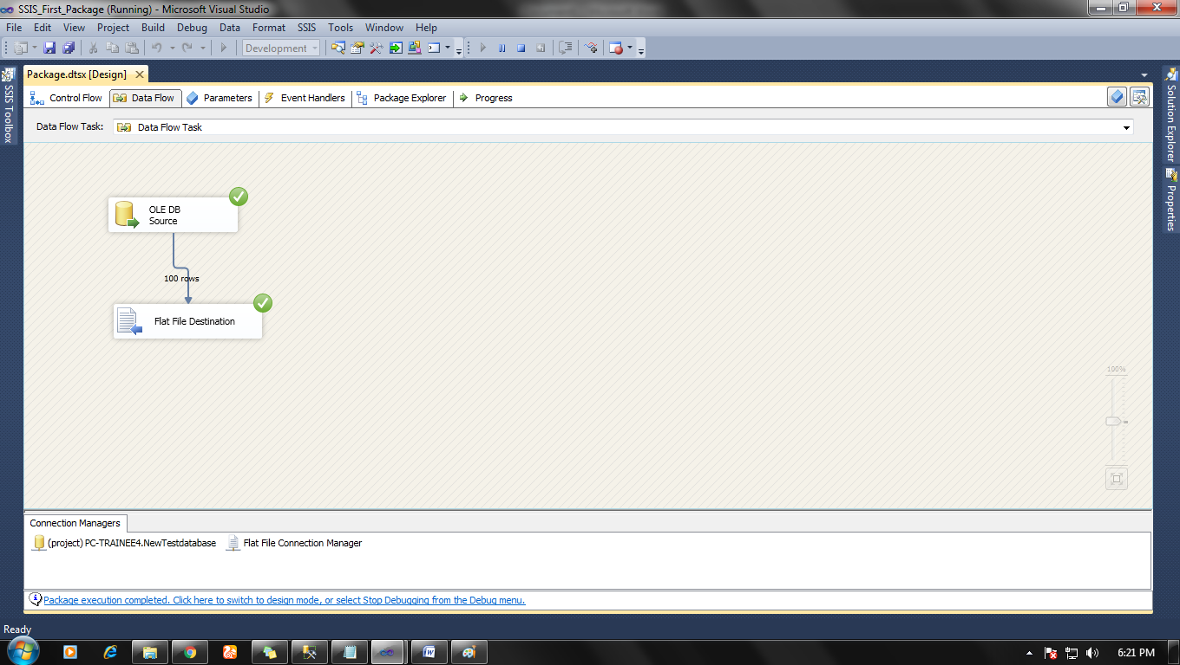

Now go to your destination file (flat file) and open that to see your result.

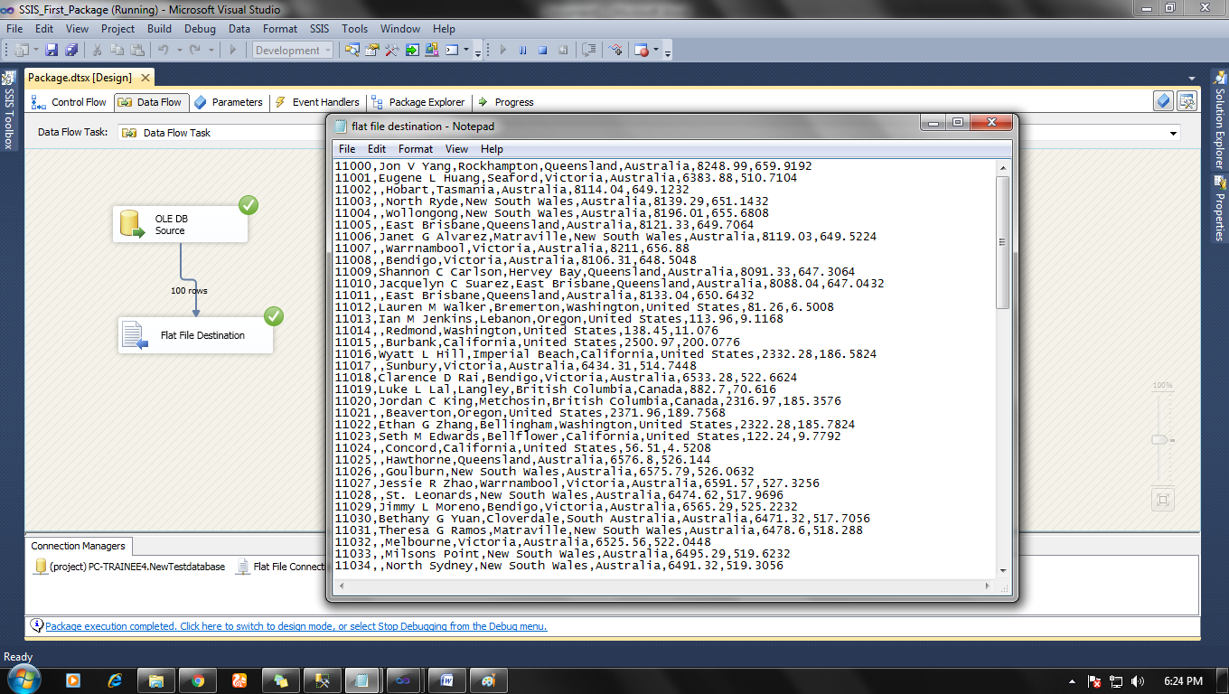

Just like it, we can create any type of data conversion and perform ETL task on our database.

**Note:** Same Procedure will work for the latest version also.